1. **What is SDLC ?**

SDLC stands for Softerware Development Life Cycle.

It is a series of steps/ Phases that provide model for Development.

1. **What is software testing?**

Software testing is a process used to identify the correctness, completeness and Quality of developed computers software.

1. **What is agile methodology?**

Agile means delivering working software in a small parts with continuous feedback and Improvements.

1. **What is SRS ?**

A software Requirnment Specification (SRS) is a complete description of the behaviour of the system to be developed.

* It include a set of use cases that describe all of the interactions that the user will have the software.

1. **What is oops ?**

Object-oriented programming has a web of interacting objects, each house-keeping its own state.

1. **Write Basic Concepts of oops ?**

* Class
* Object
* Inheritance
* Encapsulation
* Polymorphism
* Abstraction

1. **What is object ?**

Object gives permission to access functionality of class.

1. **What is class ?**

Class is a collection of data member and member functions.

1. **What is encapsulation ?**

Encapsulation is the practice of including in an object everything it needs hidden from other objects. The internal state is usually not accessible by other objects.

1. **What is inheritance ?**

Inheritance means that one class inherits the characteristics of another class. This is also called a “is a” relationship.

1. **What is polymorphism ?**

Polymorphism means “having many forms”.

* It allows different objects to respond to the same message in different ways, the response specific to the type of the object.

1. **Draw Usecase on online bill payment system (paytm)**

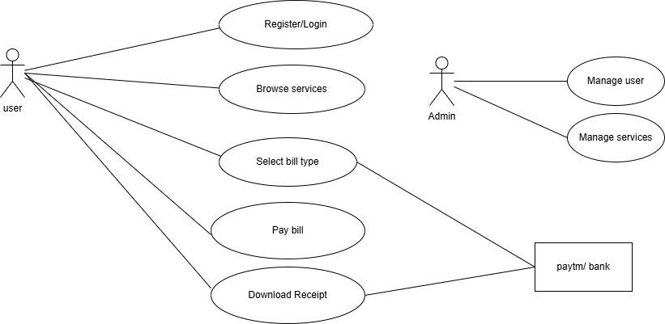

1. **Draw Usecase on banking system for customers.**

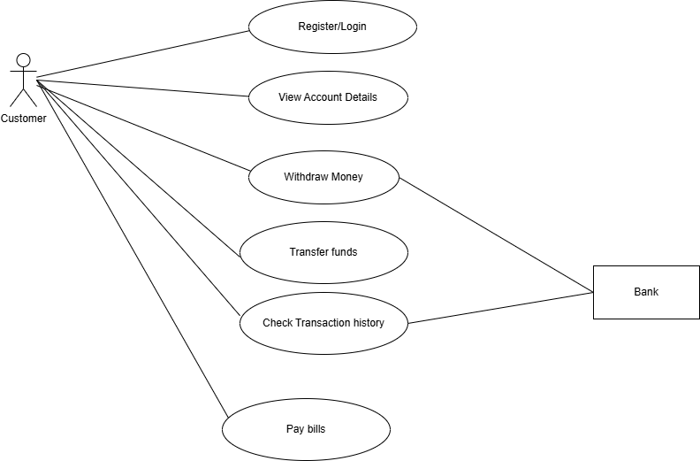

1. **Draw Usecase on Broadcasting System.**

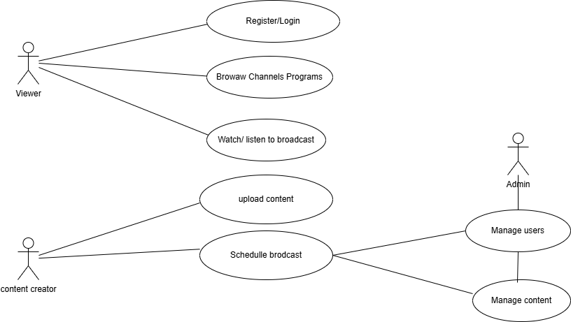

1. **Write SDLC phases with basic introduction**

* **Requirement Gathering:-**

Collect details from client about the project like; functional Requirements. and non-functional Requirements.

* **Analysis:-**

To analyse the Requirement and convert the CRS into SRS.

* **Design:-**

To prepare design/UI as per the Requirements.

* **Implementation:-**

Coding

* **Testing and Deployment:-**

To verify the correctness and quality of the software developed and deployment.

* **Maintenance:-**

Corrective – to repair a defect

Adaptive – to test in new platform

Perfective – to add a new Feature.

1. **Explain Phases of the waterfall model ?**

The classical software lifecycle Models the software development as a step by step waterfall between the various development phases.

**Applications:-**

* Requirements are very well documented, clear and fixed. Product definition is stable.
* Technology is understood and is not dynamic.
* There are no ambiguous requirements
* The project is short.

**Pros:-**

* Simple and easy to understand and use.
* Easy to managedue to the rigidity of the model. Each phase has specific deliverables and a review process.
* Clearly defined stages.
* Process and results are well documented.

**Cons:-**

* No working software is produced until late during the life cycle.
* High amounts of risk and uncertainty.
* Not a good model for complex and object-oriented projects.
* Poor model for long and ongoing projects.

1. **Write phases of spiral model ?**

**Planning:-**

Determination of objectives, alternatives and constraints.

**Risk Analysis:-**

Analysis of alternatives and identifications/ resolution of Risk.

**Engineering:-**

Development of the “Next Level” product.

**Customer Evaluation:-**

Assessment of the results of Engineering.

1. **Write agile manifesto principles ?**

* Customer satisfaction through early and continuous software delivery.
* Accommodate changing requirement through the developments process.
* Frequent delivery of working software.
* Collaboration between the business stakeholders and developers through the project.
* Support, trust, and motivate the people involved.
* Enable face to face interactions.
* Working software is the primary measure of progress.
* Agile process to supports a consistent development race.
* Attention to technical and design enhances agility.
* Simplicity.
* Self- organizing teams encourage great architectures, requirements and designs.
* Regular reflection on how to become more effective.

1. **Explain working methodology of agile model and also write pros and cons.**

* Iterative incremental model
* Work divided in small parts.
* Need to completed work in a specific time.
* Daily meeting.
* Continuous improvements.
* Continues testing and feedback.
* Customer are involved in every phase.
* Fast and flexible delivery.

**Pros:-**

* Is a very realistic approach to software development Promotes teamworkand cross training.
* Suitable for fixed or changing requirements Delivers early partial working solutions.
* Enables concurrent development and delivery within an overall.
* planned context.
* Little or no planning required Easy to manage.
* Gives flexibility to developers.

**Cons:-**

* Not suitable for handling complex dependencies.
* More risk of sustainability, maintainability and extensibility.
* Strict delivery managementdictates the scope, functionality to be delivered, and adjustments to meet the deadlines.
* There is very high individual dependency, since there is minimum documentation generated.

1. **Draw usecase on OTT Platform.**

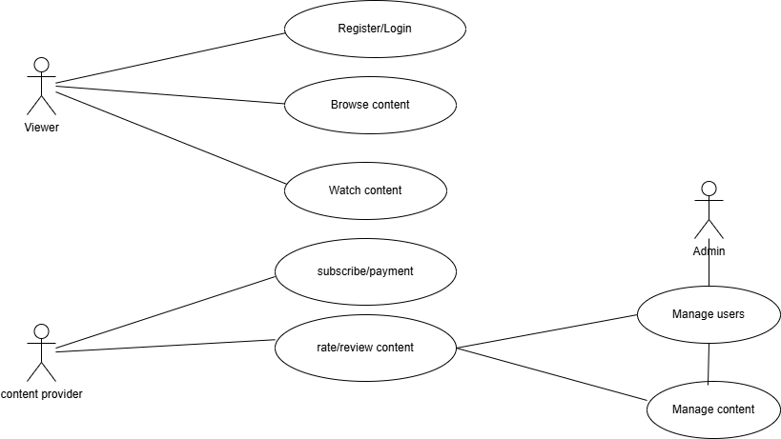

1. **Draw usecase on E-commerce application.**

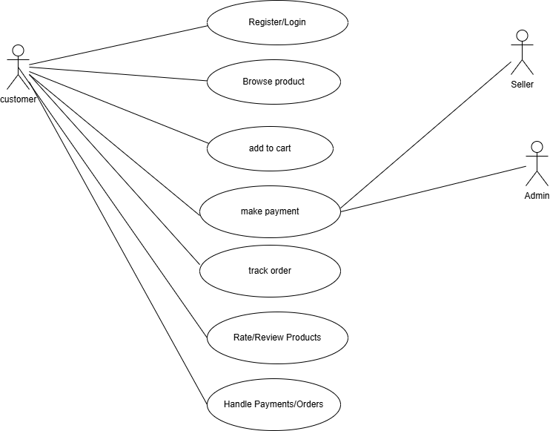

1. **Draw usecase on Online shopping product using payment gateway.**

